|  |
| --- |
| Welcome to Word  6 tips for a simpler way to work |

# Quick access to commands

At the top of your document, the **Quick Access Toolbar** puts the commands you use frequently just one click away.

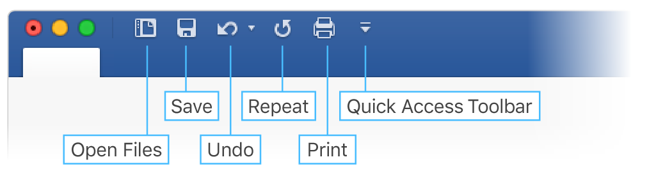

If the commands currently shown aren’t quite what you need, customize the **Quick Access Toolbar**.

Try it:

Select the **Customize Quick Access Toolbar** button and select command names to add or remove them from the **Quick Access Toolbar**.

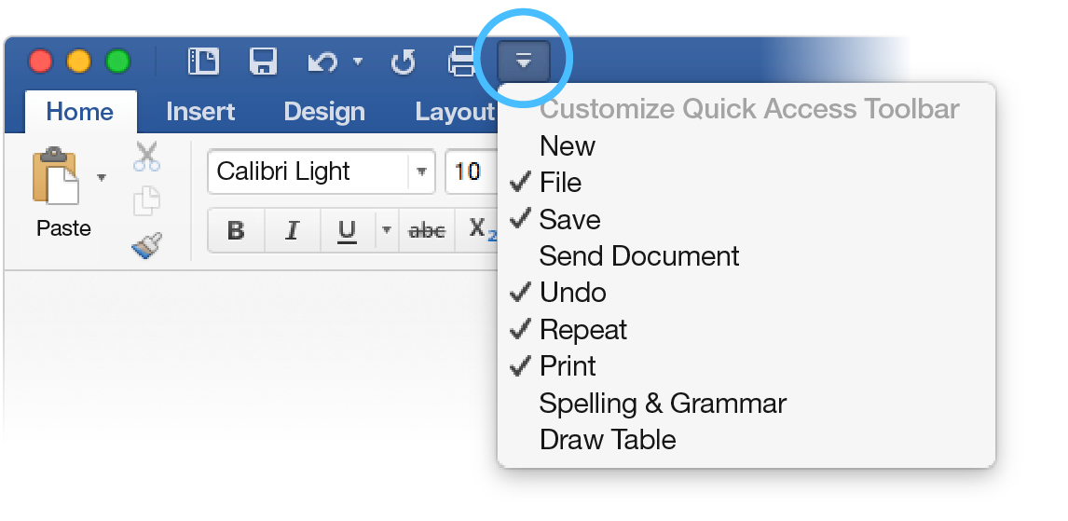

# Look professional, your way

In this document, styles like **Heading 1** and **Title** have been applied to text (**Home** tab, **Styles** gallery). That lets you quickly overhaul the look of the whole document.

Try it:

1. On the **Design** tab, select the different **Style Sets** and watch the formatting change automatically.  
   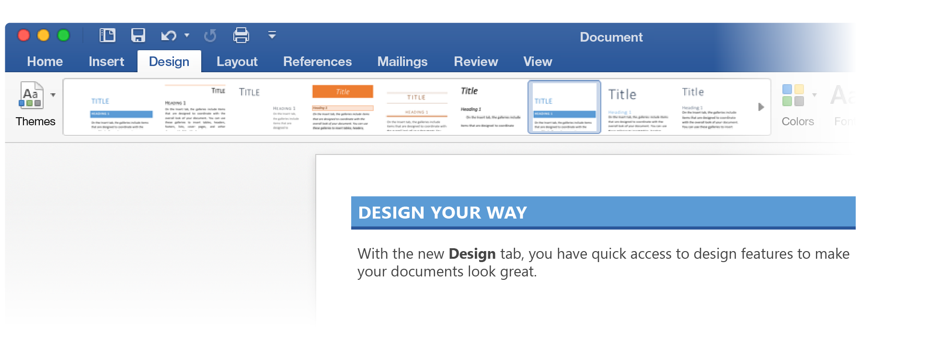
2. Go to **Themes** and watch how colors and fonts change with the various choices.  
   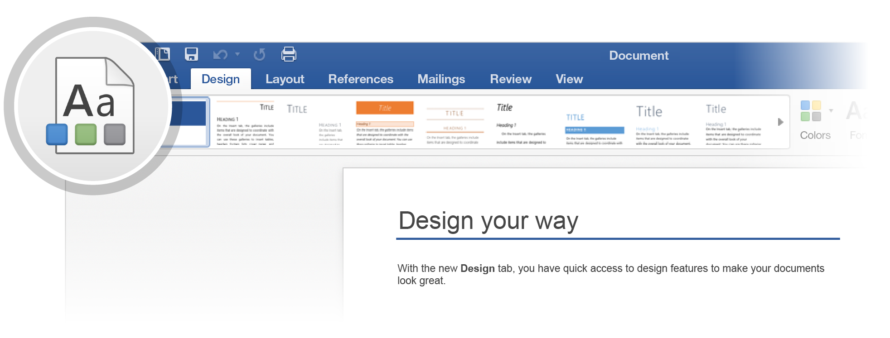
3. The **Design** tab also provides choices for fine-tuning colors, fonts, or paragraph spacing. You can also add a watermark or page border, or change the color of the page.  
   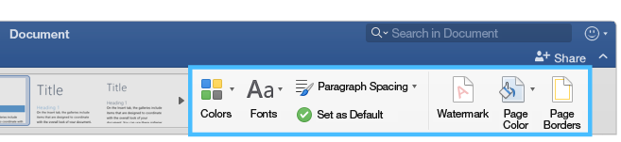

# Edit pictures without leaving Word

When it comes to pictures, Word includes options for adjusting color, cropping, removing the background, applying artistic effects, and more.

Try it:

1. Select this photograph of an otter:  
   
2. Select **Picture Format** tab, and then select **Artistic** **Effects** and select an effect, like **Mosaic** **Bubbles**.
3. To see all the formatting options, select **Picture Format** tab, and then select **Format Pane** on the right side of the app.  
   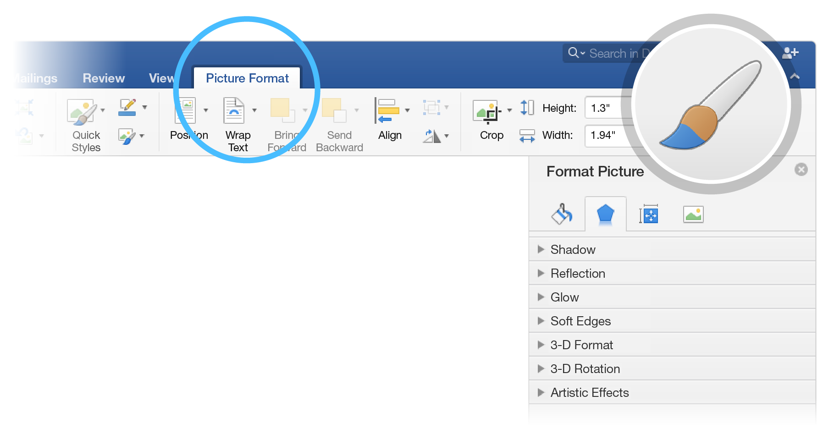
4. If you apply formatting you don’t like, press F1 to undo it, or select **Reset** under **Artistic** **Effects** in the **Format Pane** to go back to the original picture.

**Hint:** To open the **Format Pane** quickly, press Command+Shift+1.

# Explore without leaving your doc

**Smart Lookup** brings research from the web directly into Word.

Try it:

1. Select the word “Otter”
2. Go to the **References** tab and select **Smart Lookup**  
   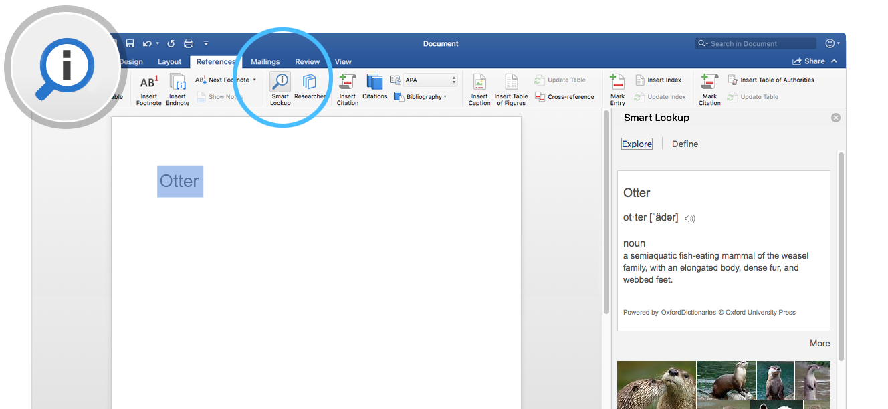

Source: Wikipedia CC-by-SA – <https://en.wikipedia.org>

1. To close out of the **Smart Lookup** pane, select the **Close** button at the top of the pane.  
   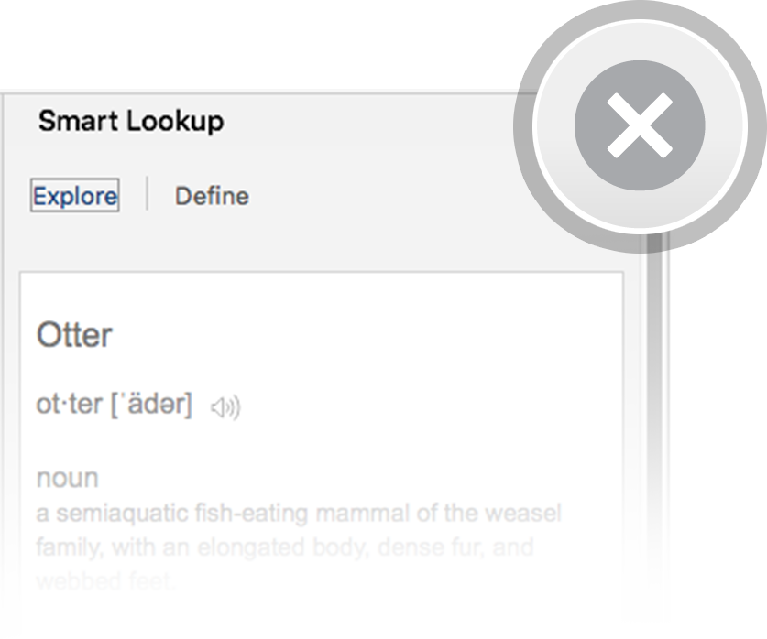

# Designed for teamwork

With your document stored online, your group can work on it together at the same time.

How it works:

1. Save your document in an online location, like OneDrive.
2. Select **Share** button from above the ribbon.  
   
3. Invite people or send a link so they can edit with you.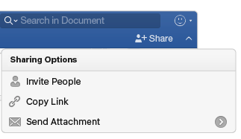

# Give feedback in comments

Comments are threaded, so you can have a conversation right next to relevant text. This is a great way to quickly add your feedback.

Try it:

1. Select somewhere in this paragraph, and then select the **Review** tab.
2. Select **New Comment**, and type something.  
   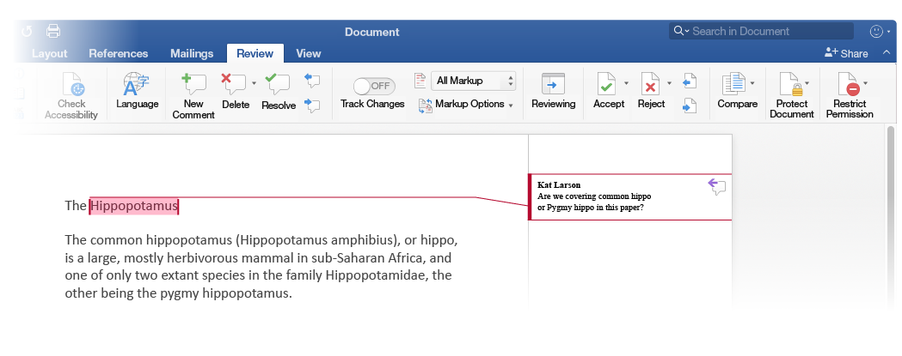
3. Notice that your comment includes a **Reply** button. Use it to respond to a comment.  
   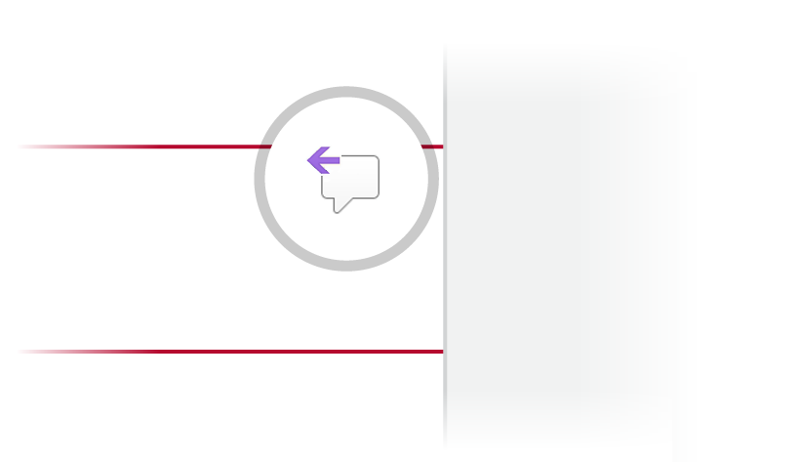

**Hint:** When you’ve taken care of feedback, get the comment out of your way without losing it: Select the comment and then select **Done** on the **Review** tab.

# More questions about Word?

|  |  |  |
| --- | --- | --- |
| Visit the Word team blog. | [Arrow pointing right with a hyperlink to the Word team blog. Select the image to visit the Word team blog](http://go.microsoft.com/fwlink/?LinkId=617174) | |
| Get help with Word for Mac. | | [Arrow pointing right with a hyperlink to help with Word for Mac. Select the image to access help with Word for Mac](http://go.microsoft.com/fwlink/?LinkId=746226) |

|  |
| --- |
| Azure Cloud  For Linux, C++ and Python Developer |

# Preface

Azure is widely used cloud platform in most of the organization as of today and many organizations is deciding to lift and shift their trading platform to Azure Cloud.

However, most of the Azure courses and documentations describe concepts with .Net, C# and Java Scripts, hence many Linux C++/Python developers like me, were struggling to grasp the concepts.

This book aims to give solid foundation for migrating Linux, C++/Python based systems, servers and applications to Azure and building new systems directly on Azure Cloud.

# Target Audience

This book expects you to have basic knowledge of any cloud computing platform and some development experience in Linux environment using C++ and Python.

# Coverage